UTHS
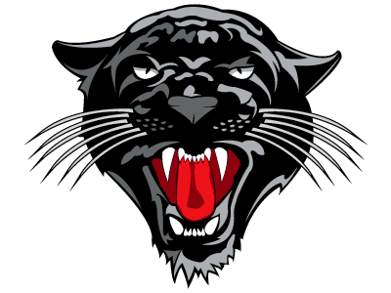

Personal Appearance & Dress Code

The school requires all students to dress in a fashion the administration judges to reflect good taste and a style appropriate for a school day. Students are expected to dress and behave in a manner that will not disrupt the educational process, constitute a health or safety hazard or violate district policy. Guidelines for student attire are:
• Dress, grooming, and accessories shall be consistent with educational objectives and may not promote alcohol, illegal drugs, tobacco, gangs, or illegal or violent behavior.
• Dress, grooming, and accessories shall not display racist, obscene, lewd, or sexual symbols, phrases, double meaning shirts, or offensive language.
• Clothing that is excessively revealing will not be allowed, such as:
Shorts - Must have 3 inch inseam or longer.
Skirts and Dresses - Must be mid-thigh.
Shirts - No tank tops or spaghetti straps (approximately 2 to 3 inches in width). No shirts that expose the midriff, stomach or excessive back area. No mesh shirts (unless a t-shirt is worn underneath).
Holey Jeans / Pants / Shorts – The holes must be 3 inches below the inseam.
• All pants must be worn at or above the waist.
• Coats and jackets must be kept in the student’s locker.
• No book bags or purses can be carried to & from class, & must be left in the student’s locker at all times.
• Hats, head kerchiefs/bandannas or other headgear will not be worn or carried in the building at any time by males or females. All hats are to be placed in the locker upon arrival to school and are to stay there for the entire school day.
• Shoes must be worn at all times.

Since it is not possible to list all infractions of these rules, it will be the responsibility of the UTHS faculty and administration to determine what is appropriate attire for the school setting.

